CUPON User Guide

Title: User Guide
Project: Cupon 1.0
Documentation identifier: Cupon/User Guide/1
Document type: Instructions for Cupon users.
Verison: 1.0 Date: April 30, 2017
Author: CS177 Group 2
Inspected: Group 2 Approved: Group 2
Submitted to Aaron Brick
Confidentiality: Commericial
Keywords: User guide, user interface, Cupon instructions

CUPON User Guide

April 30, 2017

CS 177/Group 2

Contents
Contents 2
1 Introduction 4
2 Quick Start Guide 4
3 Buying the Groupon.....................................................................................................................................................8
4 Details and Instructions of Text Messages..................................................................................................................8
5 System Requirements
9

Introduction
The CUPON application allows users a simple interface to sign-up and received discounts via Grupon their Roo from a mobile device. This document will provide instructions for using the application.

Quick Start Guide
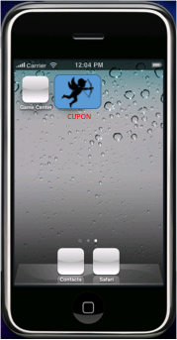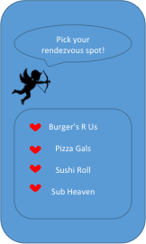
1. Tap the CUPON icon in your device menu. 2. The screen to select your restaurant will be brought up.
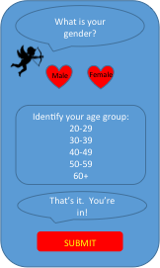
3. After choosing a restaurant, the sign-up screen will be brought up. Enter your information and tap submit.

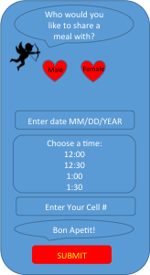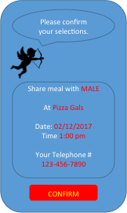
3. The options to select details of your lunch will be displayed. 4. A confirmation page will appear. Fill in the details and tap SUBMIT. Tap CONFIRM if information is correct.

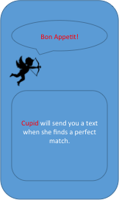
5. This page confirms CUPON has received your request. After submitting the form, a text message will be sent to the phone number you provided. The text will contain information about how to respond confirming your number and about what happens next. When a Cupon match has been made a text will be sent asking for another confirmation. A text will also be sent 24 hours in advance if a match cannot be made, or the Groupon is no longer available.

3. Buying The Groupon
Cupon is not involved in the purchase of the Groupon, and recommends buying the Groupon after meeting the other party. A text message will contain the link to purchase the Groupon and will be sent to both parties.
4. Text Messages
Following is the text content of the messages users receive after submitting an RSVP form.
Upon successful submission: User Welcome Text (Text ID 001)
Welcome to Cupon! To confirm that we have the right number, please respond with “1”.
If you were not expecting to receive this message, please ignore and further messages will not be sent.
Upon Confirmation of phone number: User instructions text (Text ID 002)
Your RSVP at [Restaurant] has been confirmed for [Date]. Now we’ll search for other people going to the same place and try to pair you up randomly. We’ll let you know when we get a match, but we won’t let you know who it is, it’s a secret. If we can’t find a match before [Date], We’ll send you a message letting you know the RSVP is cancelled and you can try again.
Upon Match: Match Notification (Text ID 003)
Good news! We found a match for [Restaurant] at [Date]. If you find out you can’t make it, please reply with “cancel” so the other person can make new plans. We’ll ask you to confirm again 24 hours before the lunch date.
Upon no Match: Unsuccessful Match Notification (Text ID 004)
Unfortunately, we could not find a match for [Restaurant] at [Date]. Please try again.
At 24 hours before RSVP Date: Second Confirmation Request (Text ID 005)
Hello! You have a lunch date with a stranger tomorrow at [Restaurant] Please confirm that you still plan on going so the other person isn’t left hanging. If we can’t get confirmation by the 5pm we’ll cancel this RSVP and you can try again.
At 5pm before date with successful confirmation: Successful Confirmation Notification (Text ID 006)
Good news! Both you and another person have confirmed for lunch tomorrow at [Restaurant].
We’ll send you a reminder one hour prior and at that point you can anonymously text your match at [ProxyNumber] to make sure you find each other. If something comes up and you can make it, you can reply with “cancel” at any time”.
At 5pm without before date w/o confirmation: RSVP Cancellation Message (Text ID 007)
Since we haven’t heard back from both parties. Your lunch date tomorrow at [Restaurant] has been cancelled. You can try to set up another date www.cupon.com
At 11pm date of: Proxy number activation message (Text ID 008)
Hello [Name] you have a mystery lunch date in an hour! Here is a number you can use to massage your date with any info you need to help meet up. If you will be delayed, use this number to let the other person know.
At 1:30 pm: Feedback Request (Text ID 009)
How did your date with [Name] at [Restaurant] go? Did you meet the person and order lunch? Please reply with “yes” or “no”. You can also email Cupon at feedback@cupon.com to let us know what happened. Thanks for using Cupon and you can set up another lunch date anytime!

5. System Requirements
The CUPON application should be installed on an iOS or Andriod compatible device.

